
How to create a git repository
Step 1: Install Git
- Go to https://git-scm.com
- Download Git for your OS (Windows / macOS / Linux)
- Install it using default settings
Step 2: Create a Project Folder
- Create a new folder on your computer
Example: Devops
- Open the folder
Step 3 : Go to GitHub Home page and click on New to create git repository
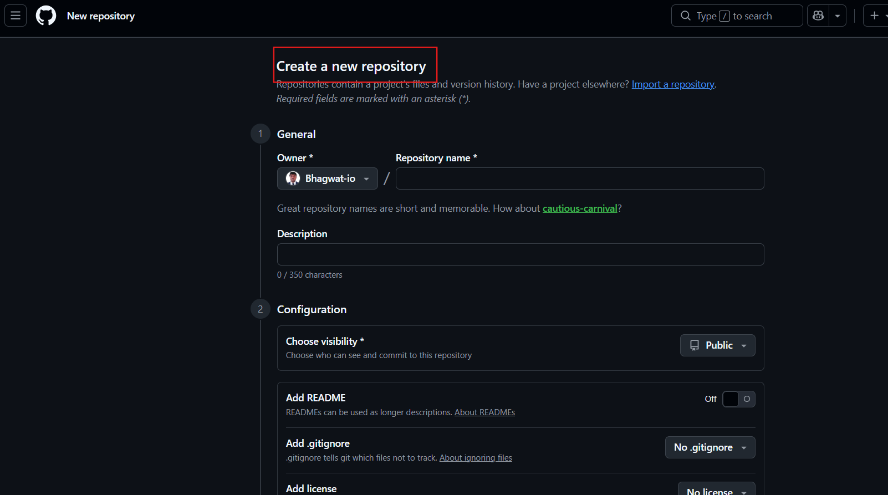

Step 4 : Give Name to repo and add description also configure repo as public or private
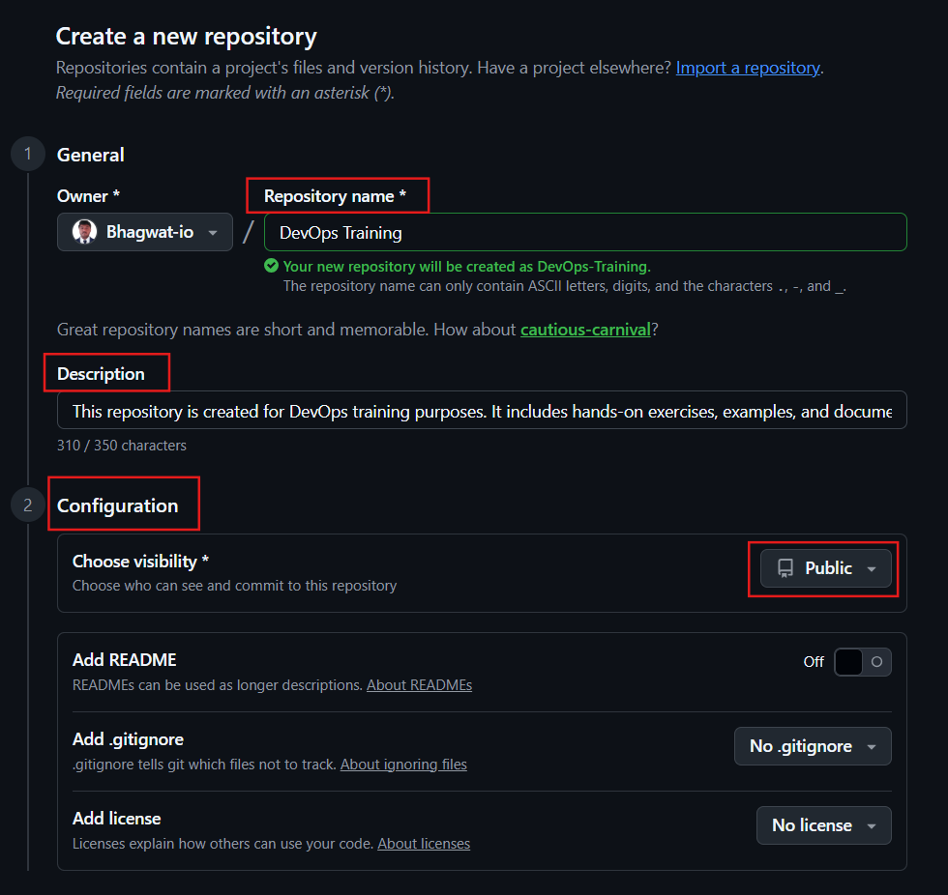
Step 5 : Go to command line and execute git commands
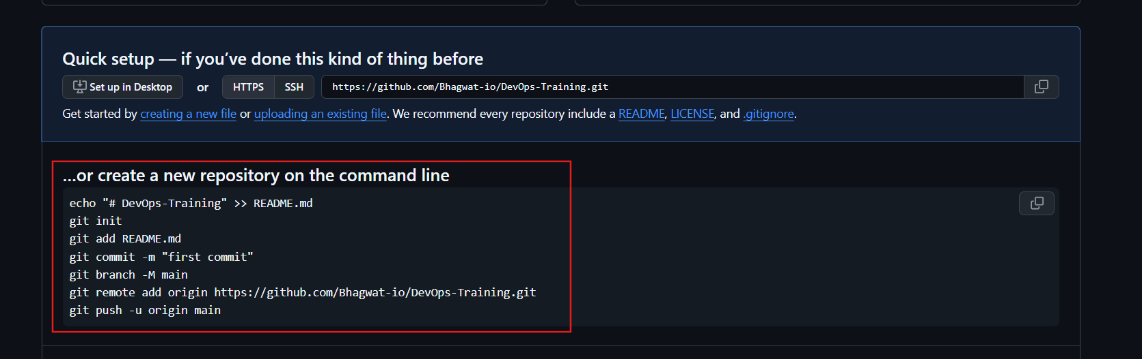

Step 6 : Commands output
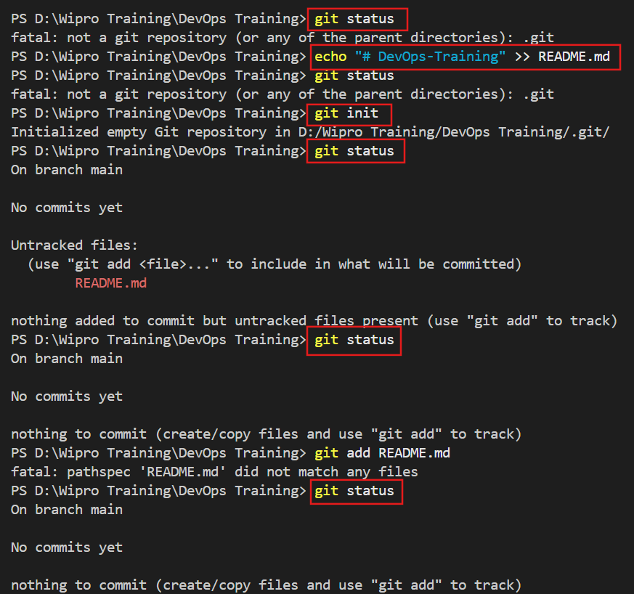
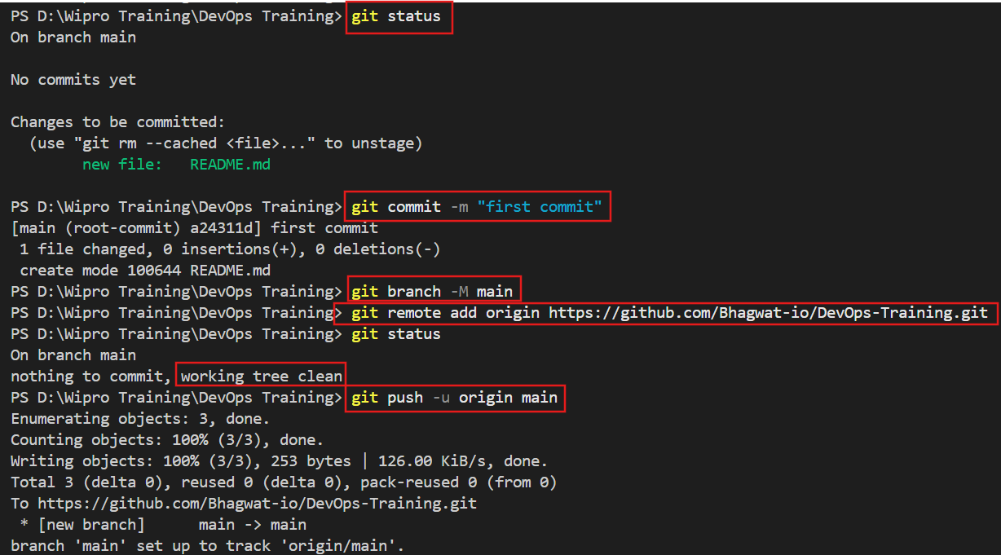
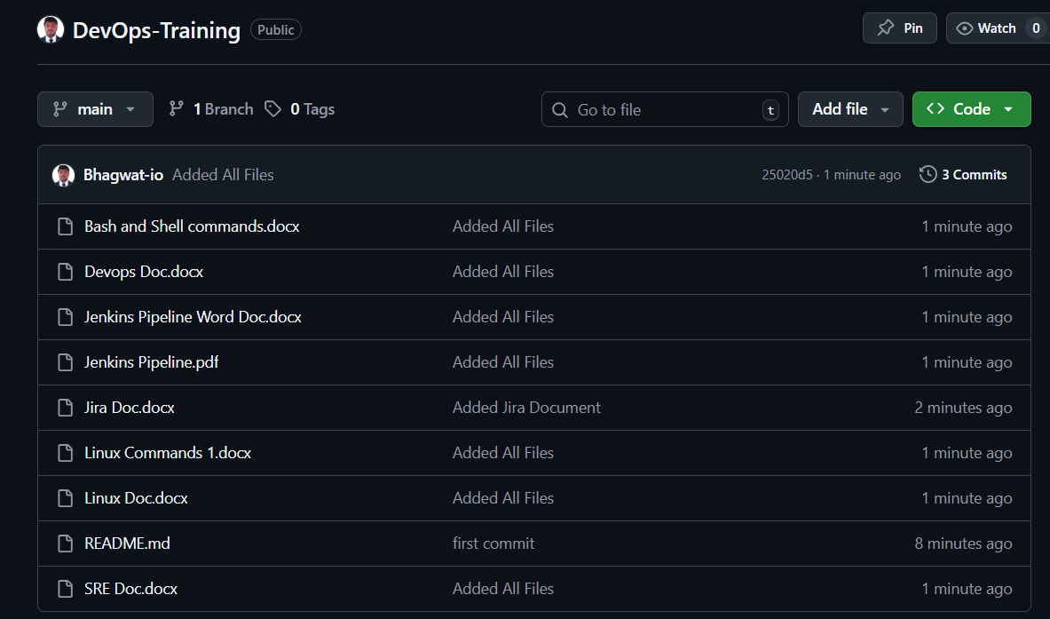

Step 8 : Now Reverse commands from local repo staging area workspace
Staging Area ➜ Workspace
git reset
What it does:
- Removes the last commit
- Files stay in staging area
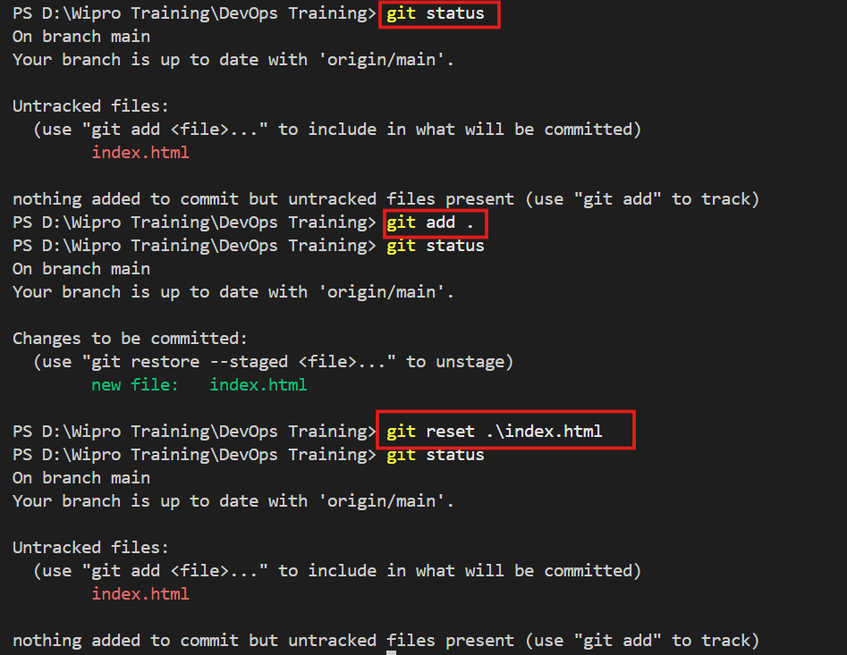
Local Repo ➜ Workspace
git revert AlphaNumeric Number
To find Alphanumeric Number use git log command
- Remove changes from Local Repository (commit)
- Keep changes in Workspace (working directory)

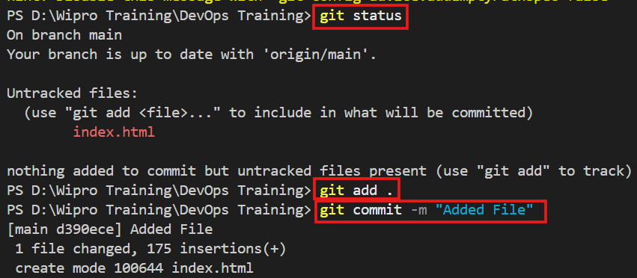

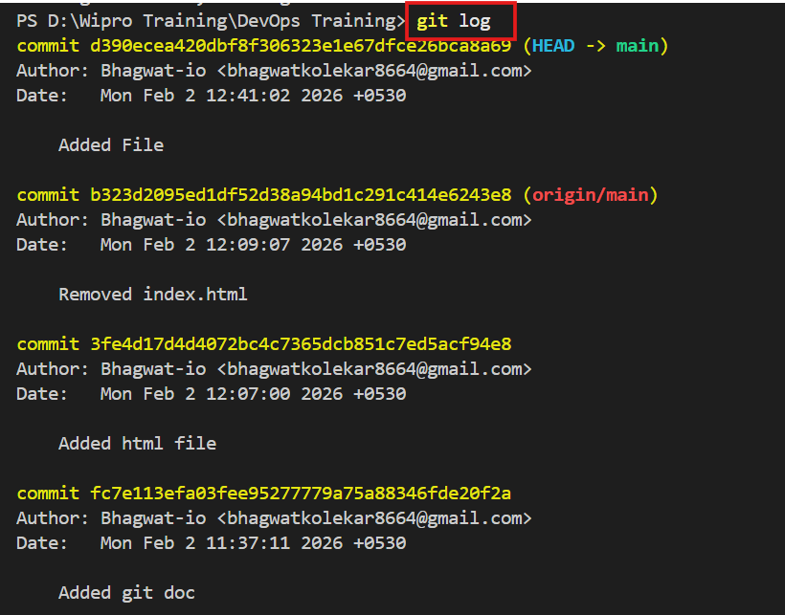

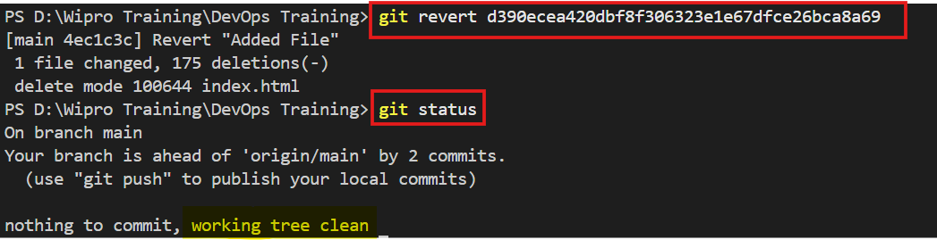
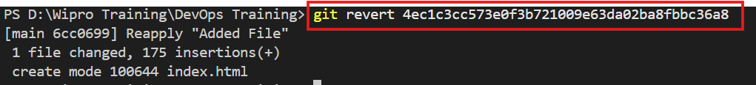

Create Another branch Using cmd
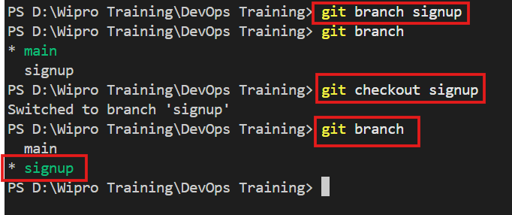

Add file to sub branch using cmds
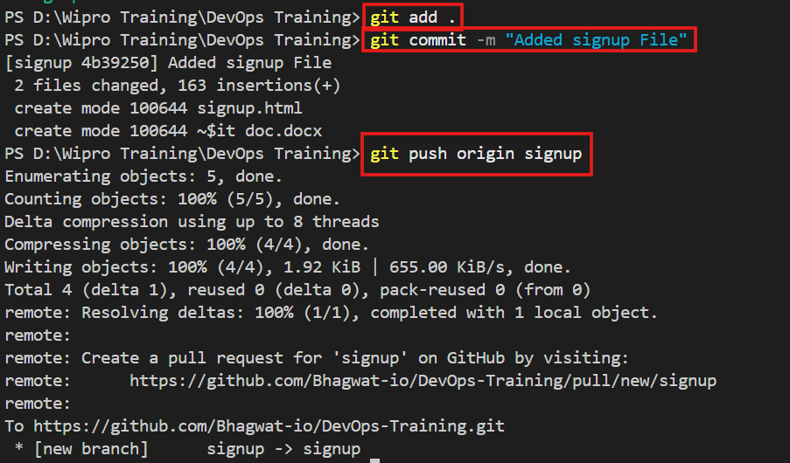

Create pull request from sub branch
- Using cmds

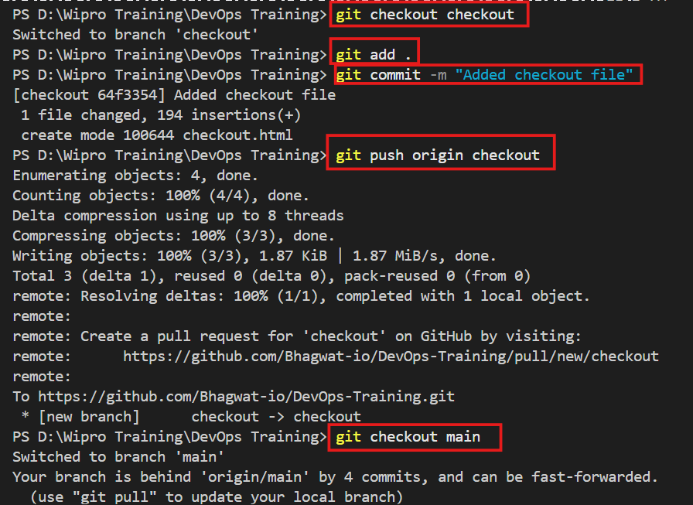

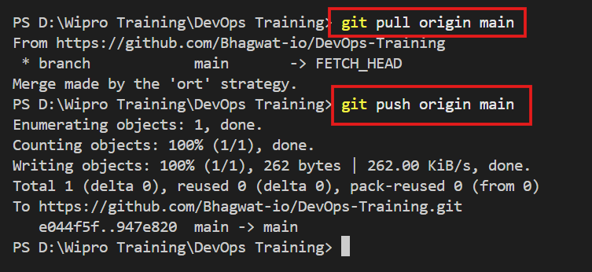

- Using github platform

Go to github and click on pull request then configure temporary repo and main repo

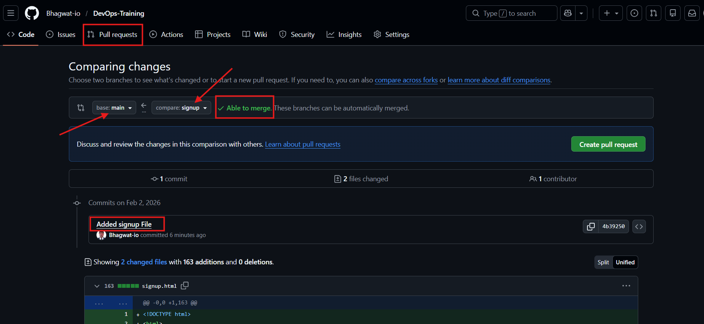

If No conflicts with main branch then click on merge pull request
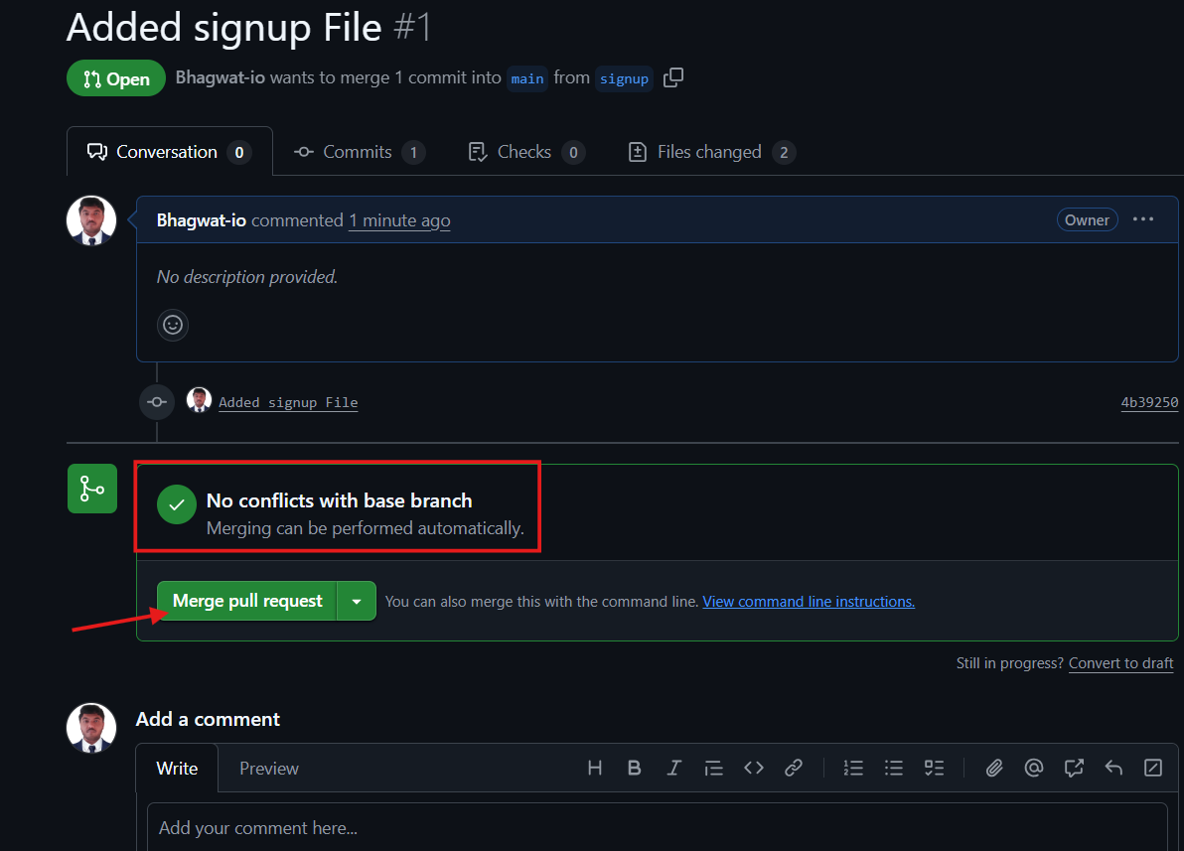
Confirm commit 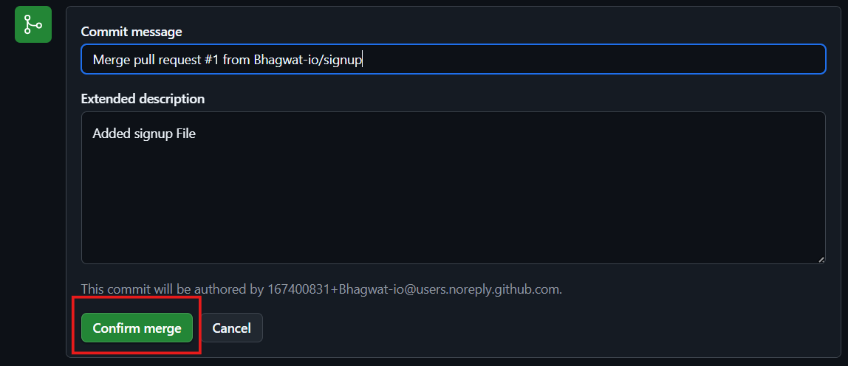

pull request successfully
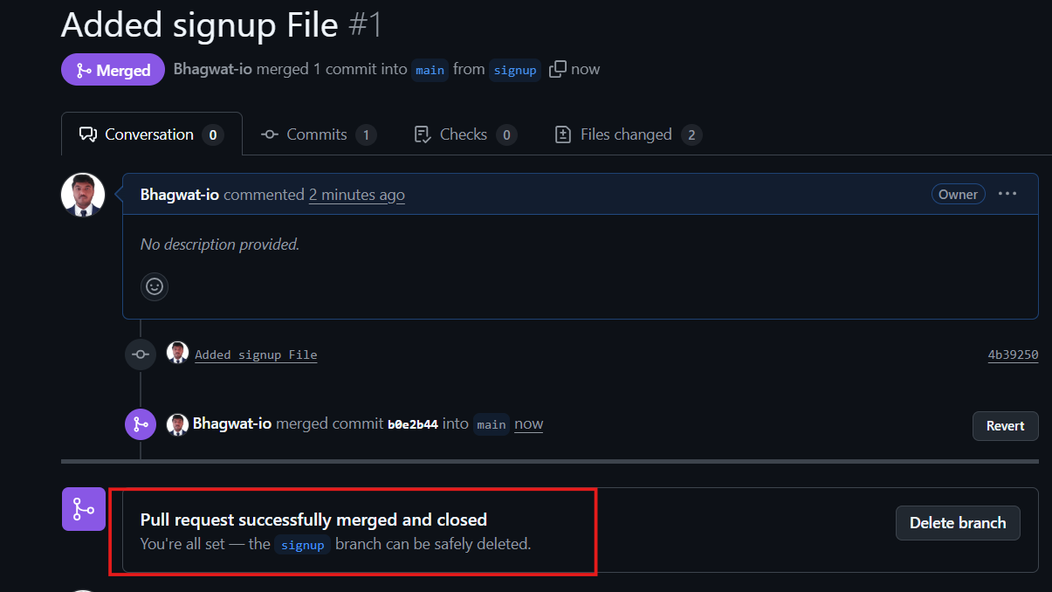

Go to git repo and check it

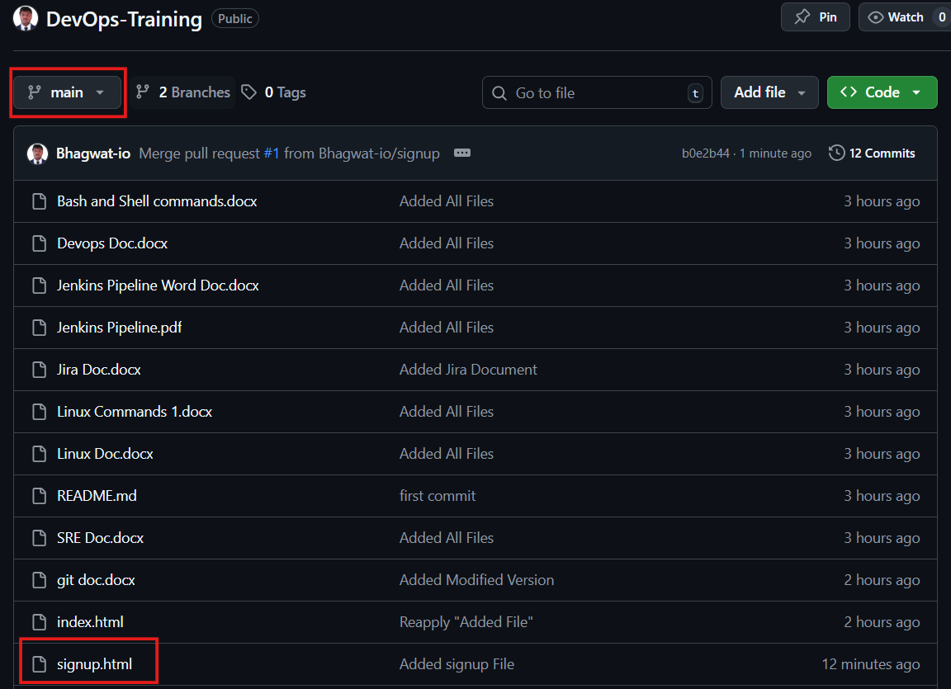

Take back to temp repo click revert button.
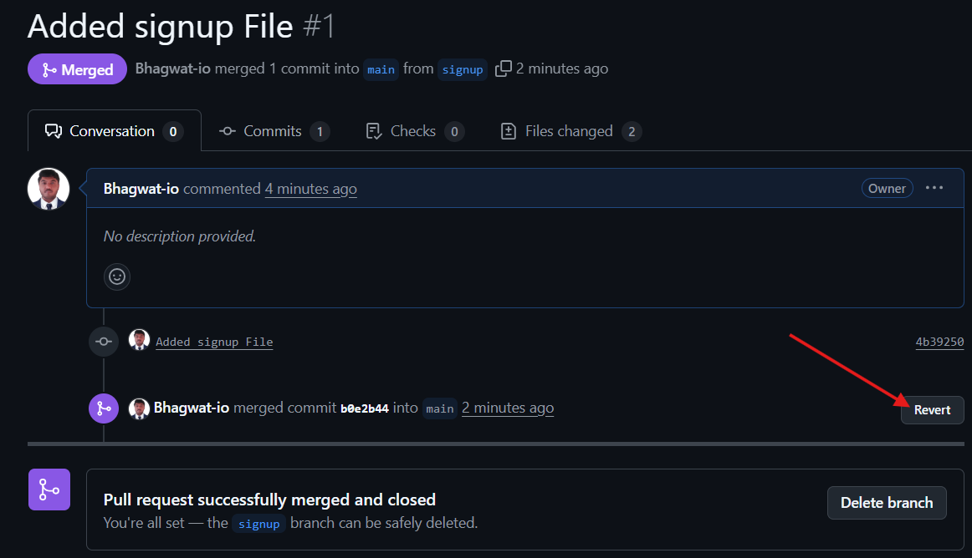
Tag to commit id
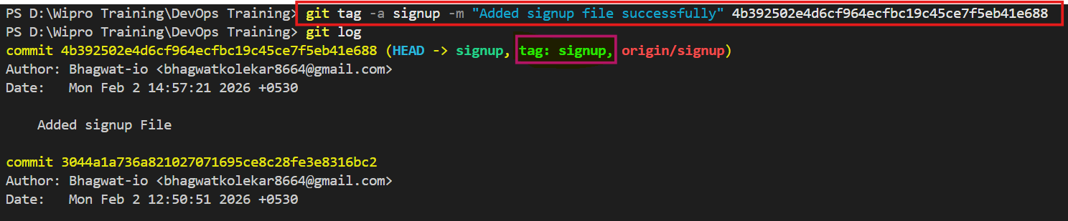
Delete branch
